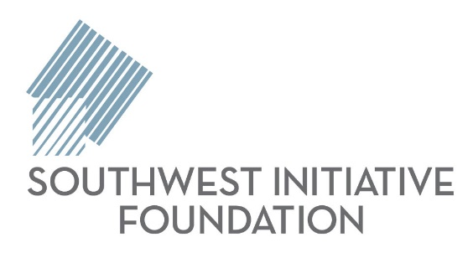

Media Contacts
Marie Zimmerman, Communications Specialist
Direct: 320-484-9121 Cell: 320-510-1678
Karen Grasmon, Communications Director
Direct: (320) 484-9112

About Grow Our Own
In 2016, after decades of working to identify and address a wide range of economic and social issues, the Southwest Initiative Foundation board of directors made the strategic decision to focus the foundation’s efforts in a way that will deliver the greatest impact for the future of the region.
Research shows there is growing income disparity among families with children. Median incomes for families in the bottom 20 percent of the income distribution declined by 9 percent between 1999 and 2014, while median incomes for families in the top 20 percent rose by 9 percent during that same period. As communities and neighborhoods across the region change, kids from low income families are facing obstacles that remove stepping stones to upward mobility. This is commonly known as “the opportunity gap.”
These kids are our future employees, entrepreneurs, community leaders, volunteers, homeowners and taxpayers. The vitality of our region and the strength of our rural economy depend on everyone being able to contribute, and it starts before birth. We need to ensure all our kids get the best possible start to life. We are calling this work “Grow Our Own.”
We believe preparing the next generation to reach their full potential is a long-term economic development strategy with a triple bottom line return.
- Our kids win. They are healthy, well-educated and ready to participate in the world of work.
- Our communities win. Precious resources that might otherwise go to short-term remediation such as public assistance and incarceration are instead available for investment in infrastructure and innovation.
- Our businesses win. More young people are entering the world of work ready to fully participate.
But most importantly, we’re supporting all our southwest Minnesota kids because it’s simply the right thing to do.

About the Summit
The Grow Our Own Summit brings people together to learn, share ideas, and become equipped to take action in their own communities. We all have a role to play in helping our next generation succeed, and this event is a great way to inspire continued and new local efforts. Sponsors for this event are the Bush Foundation, Heroic Productions, Pioneer Public Television, and Southwest Minnesota State University.

About the Research

Grow Our Own focuses on five pillars a child needs to succeed — stable families and parenting, quality early childhood experiences, engagement during the K-12 years, safe and caring communities and pathways to successful careers. This cradle to career framework is based on The Saguaro Seminar: Civic Engagement in America, “Closing the Opportunity Gap Report,” Harvard Kennedy School (2016).
The 2018 Grow Our Own summit illustrates ideas from “Restoring the American Dream,” a 2018 report from the US Partnership on Mobility from Poverty. Convened by the Urban Institute and funded by the Bill and Melinda Gates Foundation, thought leaders from across the country and from all sectors spent two years looking at the barriers to upward mobility for families in poverty. They identified five strategies that align well with Grow Our Own efforts — change the narrative, create access to good jobs, create safe, caring communities; provide support that empowers and transform data use.
In 2016, Southwest Initiative Foundation (SWIF) commissioned the Carsey School of Public Policy at the University of New Hampshire to release the research paper titled “A Profile of Youth Poverty and Opportunity in Southwestern Minnesota,” which helped inform the launch of Grow Our Own. Dr. Mattingly, director of research on vulnerable families at the Carsey School of Public Policy and a research assistant professor of sociology at the University of New Hampshire, co-authored the report with Andrew Schaefer and Douglas Gagnon.

About Southwest Initiative Foundation
Southwest Initiative Foundation (SWIF) is a nonprofit community foundation connecting people, investing in ideas and building communities to create a southwest Minnesota where all people thrive. Our region includes the 18 counties and two Native Nations of southwest Minnesota. Since its founding in 1986, SWIF has distributed more than $75 million through its grantmaking and business finance programs.
Quick Facts: In the last fiscal year (July 1, 2017– June 30, 2018) we:
- Made 41 loans totaling $2.1 million through our Business Finance and Microenterprise Loan Programs.
- Made our 1,000th loan to FBT Sawmill in Steen (Nobles County).
- Awarded 568 grants totaling $1.6 million
- $25,000 in early care and education
- $50,000 in responsive grants
- Raised $3.1 million in gifts to all our funds from the people, businesses and organizations that care about southwest Minnesota and make our work possible.

