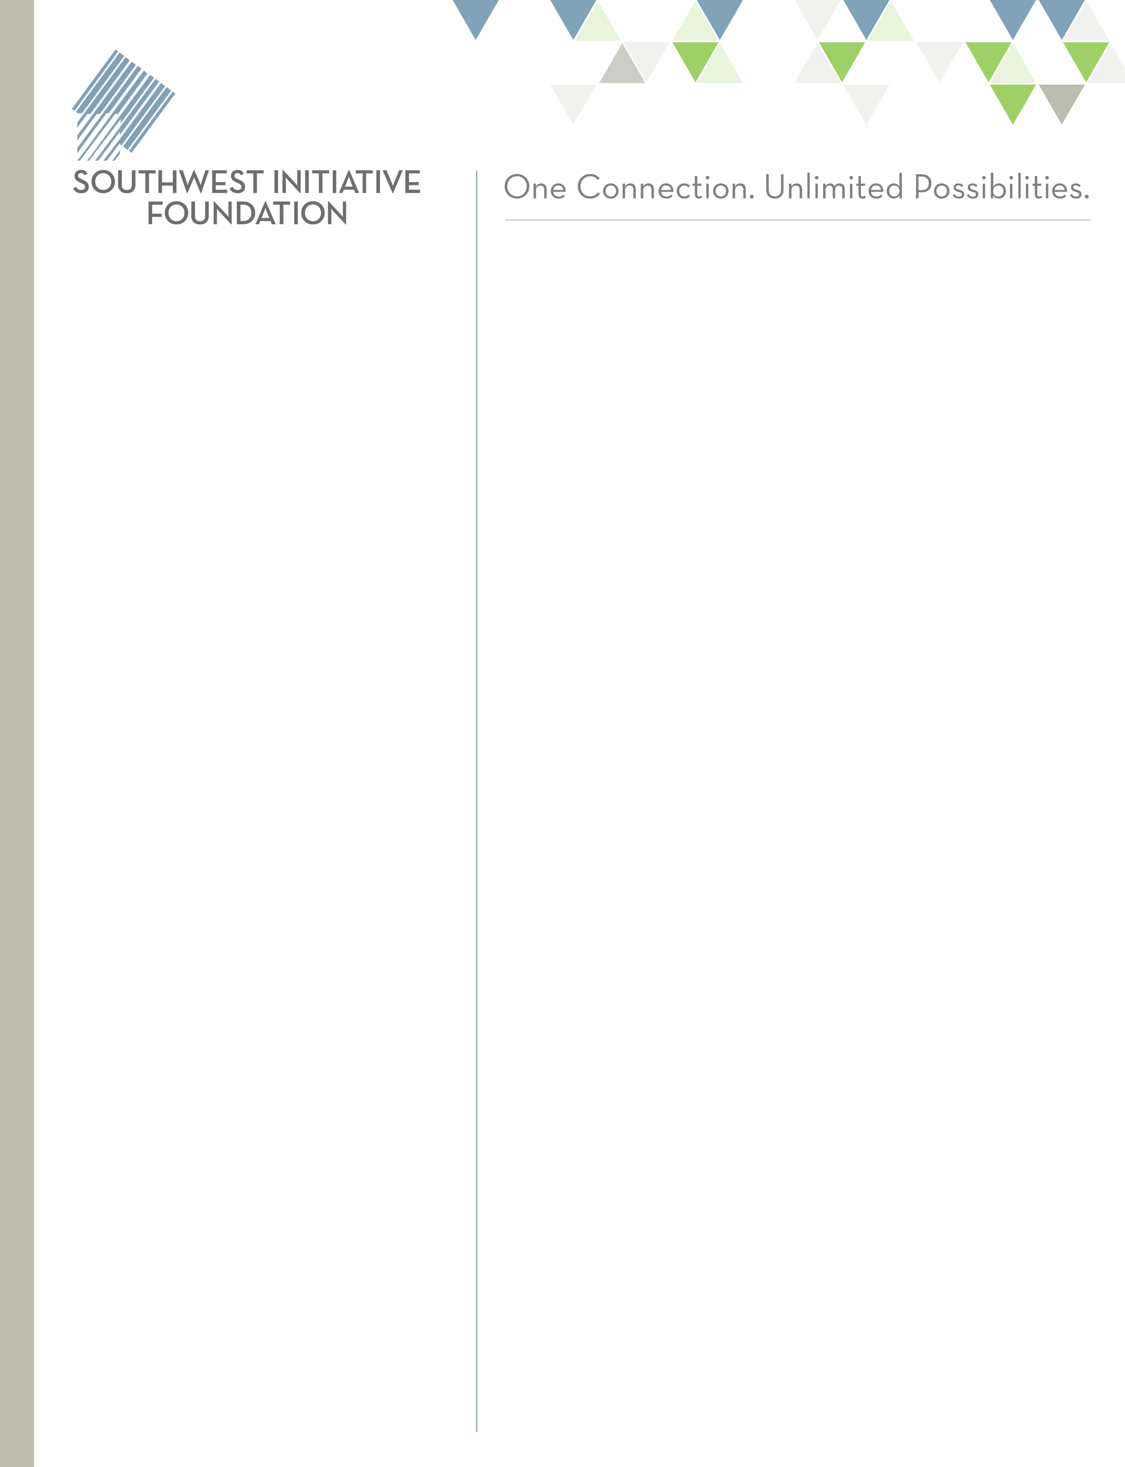

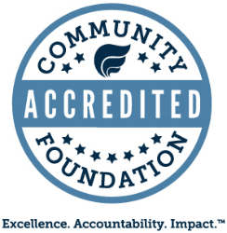

**AREAS OF FOCUS**

* **PreK-3rd Grade Alignment** –

enhancing the continuity and consistency of learning for children birth to grade 3 through trainings and professional development, resource development, strategy implementation, quality staff planning time or building community-wide approaches.

* **Social and Emotional Development** – building resilient communities through the enhancement of existing or development of new trainings, prevention, education and programs that continue to have a far-reaching impact.
* **Early Care and Education** –

helping to increase access to and availability of high-quality early care and education environments through (including, but not limited to) staff development, curriculum and/or assessment implementation, Parent Aware rating attainment, expansion of number of children in care, etc.

Funding requests of up to $5,000 will be considered. We expect the project will be completed within 12 months of the grant award date, at which time a final report will be due.

This is a competitive grant program. It is our expectation these funds will help our regional nonprofits address early care and education. Grants will be awarded in May 2018.

*Questions can be directed to Nancy Fasching at (320) 484-9104 or* [*nancyf@swifoundation.org*](mailto:nancyf@swifoundation.org)*.*

***Applications Due by 5 p.m. on April 20, 2018***

Request for Proposals

Early Care and Education Grant

15 3rd Avenue NW  
Hutchinson, MN 55350  
(800) 594-9480  
info@swifoundation.org  
www.swifoundation.org

*The Southwest Initiative Foundation (SWIF) is offering a third round of early care and education grants to support 501(c)3 nonprofit service organizations directly serving our southwest Minnesota communities.*

The Southwest Initiative Foundation is committed to supporting early childhood efforts. Our goal is that all children in southwest Minnesota are ready to learn and succeed at their full potential.

Confirmed in Compliance with National Standards for U.S. Community Foundations

An Equal Opportunity Provider and Employer



**Application Process**

* Applicants must complete the pre-application questionnaire found at: <https://swifoundation.org/grow/grants/pre-application-questionnaire/>
  + Please select *Early Childhood Initiative* as the funding priority you are applying for
* You will receive an e-mail confirming our receipt of your pre-application questionnaire
* For consideration of the Early Care and Education grant RFP, please complete the additional questions below in a word document and email them to [grants@swifoundation.org](mailto:grants@swifoundation.org) with the subject line *“2017* *Early Care and Education Grant Additional Questions”* by the grant deadline of **5 p.m.** **April 20, 2018**
* Upon receipt, your pre-application questionnaire and additional questions will be filed together and assigned to a staff grant reviewer for consideration. They will contact you with

questions and schedule a site visit, if deemed necessary

* You will be informed after the final decision is made on **May 18, 2018**

**Grant Guidelines**

* All proposals must demonstrate a benefit within the following 18 counties in southwest Minnesota: Big Stone, Chippewa, Cottonwood, Jackson, Kandiyohi, Lac qui Parle, Lincoln, Lyon, McLeod, Meeker, Murray, Nobles, Pipestone, Redwood, Renville, Rock, Swift, and

Yellow Medicine

* Proposals must be submitted by an independent 501(c)(3) organization, a unit of

government, or by a public agency

* Funding requests of up to $5,000 will be considered; Matching funds are not necessary
* Projects must be completed within 12 months of the grant award date
* Only one grant application may be submitted per organization
* A final report is due following the grant period

**Grant Exclusions**

**Ineligible organizations or activities include:**

* Individuals, businesses, or other for-profit organizations
* General operating expenses or specific religious purposes
* Capital funding, campaigns or endowments
* Funds for re-granting

**ADDITIONAL QUESTIONS:**

1. Describe the need for engaging in the proposed early care and education project.
2. Describe how your approach is based on established best practices in early care and education that will most likely lead to the desired outcomes for the organization.
3. Describe how this project impacts southwest Minnesota children and families.
4. List any other organzations you are collaborating with on this project.
5. Any other information you would like to provide.



**Early Care and Education Grant Award Selection Criteria**

*\*Proposals that are in line with the criteria below will receive priority consideration in our grant review process.*

* Applicant organization meets all eligibility criteria and any other requirements specified in this

RFP

* Applicant organization’s mission and primary programs, services, and/or activities strongly

align with the Southwest Initiative Foundation’s mission

* Impact — projects that demonstrate an overall impact within Southwest Initiative

Foundation’s 18 county region through an evidence-based approach

* Collaboration/partnership — projects that work with other organizations in unique and

impactful ways

* Community need — projects that successfullly address an identified need and/or opportunity
* Measurable results — projects that can show quantitative results in this grant’s areas of

focus

* Asset-based approaches — projects that maximize the strengths, talents and resources of

the local community

* Replicability – projects that can easily be replicated throughout the SWIF region

**How to Apply**

* Complete the Pre-Application Questionnaire; select *Early Childhood Initiative* under funding

priority

* You will receive an email confirming our receipt of your pre-application questionnaire
* Complete the additional questions in a word document and email them to [grants@swifoundation.org](mailto:grants@swifoundation.org) with the subject line *“2018* *Early Care and Education Grant Additional Questions”* prior to **5 p.m. on April 20, 2018**
* Upon receipt, your complete application is assigned to a staff grant reviewer. They will contact you with questions and schedule a site visit, if deemed necessary
* Final decisions will be announced via email on **May 18, 2018**